SESSION – 9(Kashish)

Q.1) Create a Bootstrap layout for a Flipkart-style product card page: use a container with a row, and display three product cards side by side using the grid system's columns.
Ans).
<!DOCTYPE html>
<html lang="en">
<head>
<meta charset="UTF-8">
<meta name="viewport" content="width=device-width, initial-scale=1.0">
<title>Flipkart Product Cards</title>
<!-- Bootstrap CSS -->
<link href="https://cdn.jsdelivr.net/npm/bootstrap@5.3.3/dist/css/bootstrap.min.css" rel="stylesheet">
<style>
body {
background-color: #f1f3f6;
}
.product-card {
border: none;
box-shadow: 0 2px 8px rgba(0, 0, 0, 0.15);
transition: 0.3s;
}
.product-card:hover {
transform: scale(1.03);
}
.product-card img {
height: 220px;
object-fit: cover;
}
.price {
color: green;
font-size: 20px;
font-weight: bold;
}
.buy-btn {
background-color: #ff9f00;
color: white;
border: none;
}
</style>
</head>
<body>
<div class="container py-5">
<h2 class="text-center mb-4">Featured Products</h2>
<!-- Bootstrap Row -->
<div class="row g-4">
<!-- Product 1 -->
<div class="col-md-4">
<div class="card product-card h-100">
<img src="/Headphone.avif" class="card-img-top" alt="Headphones">
<div class="card-body text-center">
<h5 class="card-title">Wireless Headphones</h5>
<p class="card-text">
High-quality sound with a comfortable design.
</p>
<p class="price">₹1,999</p>
<button class="btn buy-btn">Add to Cart</button>
</div>
</div>
</div>
<!-- Product 2 -->
<div class="col-md-4">
<div class="card product-card h-100">
<img src="/Smart Watch.webp" class="card-img-top" alt="Smart Watch">

<div class="card-body text-center">
<h5 class="card-title">Smart Watch</h5>
<p class="card-text">
Track your fitness and stay connected.
</p>

<p class="price">₹2,499</p>

<button class="btn buy-btn">Add to Cart</button>
</div>
</div>
</div>

<!-- Product 3 -->
<div class="col-md-4">
<div class="card product-card h-100">
<img src="/Laptop.avif" class="card-img-top" alt="Laptop">

<div class="card-body text-center">
<h5 class="card-title">Laptop</h5>
<p class="card-text">
Powerful performance for work and study.
</p>

<p class="price">₹45,999</p>

<button class="btn buy-btn">Add to Cart</button>
</div>
</div>
</div>
</div>
</div>
<!-- Bootstrap JavaScript -->
<script src="https://cdn.jsdelivr.net/npm/bootstrap@5.3.3/dist/js/bootstrap.bundle.min.js"></script>
</body>
</html>
Result:
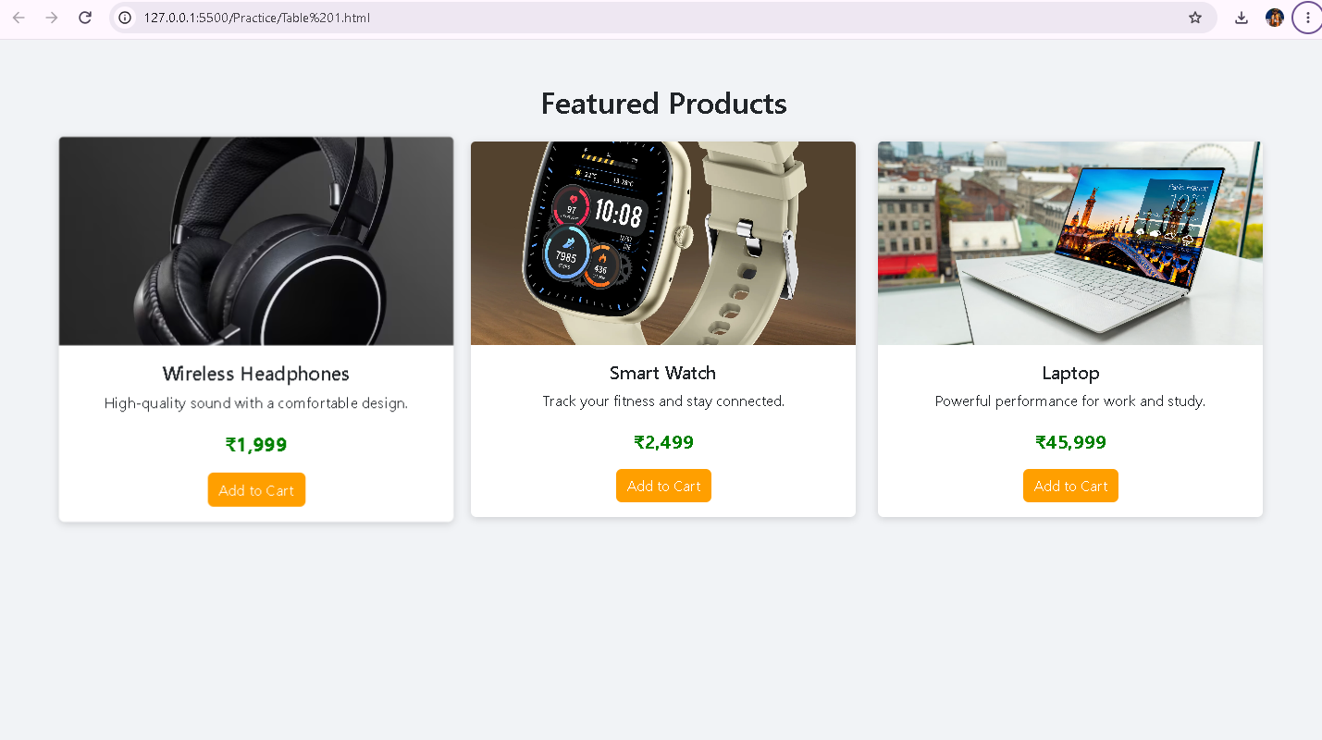

Q.2) Build a Zomato restaurant listing page using Bootstrap grid: arrange two restaurant cards per row, each card showing a restaurant name and a short description.<br><br><em><strong>Hint:</strong> Use col-6 inside a row to get two equal columns per row.</em>
Ans).
<!DOCTYPE html>
<html lang="en">
<head>
<meta charset="UTF-8">
<meta name="viewport" content="width=device-width, initial-scale=1.0">

<title>Zomato Restaurant Listing</title>

<!-- Bootstrap CSS -->
<link href="https://cdn.jsdelivr.net/npm/bootstrap@5.3.3/dist/css/bootstrap.min.css" rel="stylesheet">

<style>
body {
background-color: #f8f9fa;
}

.restaurant-card {
border: none;
border-radius: 10px;
box-shadow: 0 2px 8px rgba(0, 0, 0, 0.15);
transition: 0.3s;
}

.restaurant-card:hover {
transform: scale(1.03);
}
</style>
</head>
<body>
<div class="container py-5">
<h1 class="text-center mb-4">Popular Restaurants</h1>

<!-- Bootstrap Row -->
<div class="row g-4">

<!-- Restaurant 1 -->
<div class="col-6">
<div class="card restaurant-card p-3">
<div class="card-body">
<h4 class="card-title">The Pizza House</h4>
<p class="card-text">
Delicious pizzas with fresh toppings and cheesy flavors.
</p>
</div>
</div>
</div>

<!-- Restaurant 2 -->
<div class="col-6">
<div class="card restaurant-card p-3">
<div class="card-body">
<h4 class="card-title">Spice Garden</h4>
<p class="card-text">
Enjoy authentic Indian food with traditional spices.
</p>
</div>
</div>
</div>

<!-- Restaurant 3 -->
<div class="col-6">
<div class="card restaurant-card p-3">
<div class="card-body">
<h4 class="card-title">Burger Point</h4>
<p class="card-text">
Fresh and tasty burgers served with crispy fries.
</p>
</div>
</div>
</div>

<!-- Restaurant 4 -->
<div class="col-6">
<div class="card restaurant-card p-3">
<div class="card-body">
<h4 class="card-title">Sweet Treats</h4>
<p class="card-text">
Cakes, pastries, and delicious desserts for everyone.
</p>
</div>
</div>
</div>
</div>
</div>
</body>
</html>

Result:
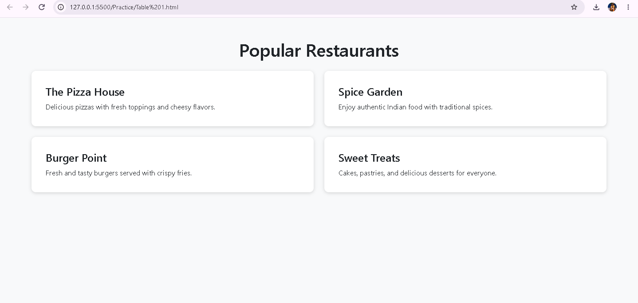

Q.3) Design a BookMyShow-like movie details section using Bootstrap: place a movie poster image in one column and movie details (title, genre, rating, and a 'Book Now' button) in the second column, using the grid system.
Ans).
<!DOCTYPE html>
<html lang="en">
<head>
<meta charset="UTF-8">
<meta name="viewport" content="width=device-width, initial-scale=1.0">

<title>Movie Details</title>

<!-- Bootstrap CSS -->
<link href="https://cdn.jsdelivr.net/npm/bootstrap@5.3.3/dist/css/bootstrap.min.css" rel="stylesheet">

<style>
body {
background-color: #f5f5f5;
}

.movie-section {
background-color: #ffffff;
padding: 30px;
border-radius: 10px;
box-shadow: 0 2px 10px rgba(0, 0, 0, 0.15);
}

.movie-poster {
width: 100%;
max-width: 350px;
border-radius: 10px;
}

.rating {
font-size: 20px;
font-weight: bold;
color: #ff9f00;
}

.book-btn {
background-color: #e50914;
color: white;
border: none;
padding: 10px 25px;
font-size: 18px;
}
</style>
</head>

<body>

<div class="container py-5">

<div class="movie-section">

<!-- Bootstrap Row -->
<div class="row align-items-center">

<!-- Movie Poster Column -->
<div class="col-md-5 text-center">
<img src="/Avengers - End Game.jpg"
alt="Avengers: Endgame"
class="movie-poster">
</div>

<!-- Movie Details Column -->
<div class="col-md-7 mt-4 mt-md-0">

<h1>Avengers: Endgame</h1>

<p><strong>Genre:</strong> Action, Adventure, Sci-Fi</p>

<p class="rating">⭐ 4.8 / 5</p>

<p>
The Avengers assemble once again to reverse the damage
caused by Thanos and save the universe.
</p>

<button class="btn book-btn">
Book Now
</button>

</div>

</div>

</div>

</div>

</body>
</html>

Result:
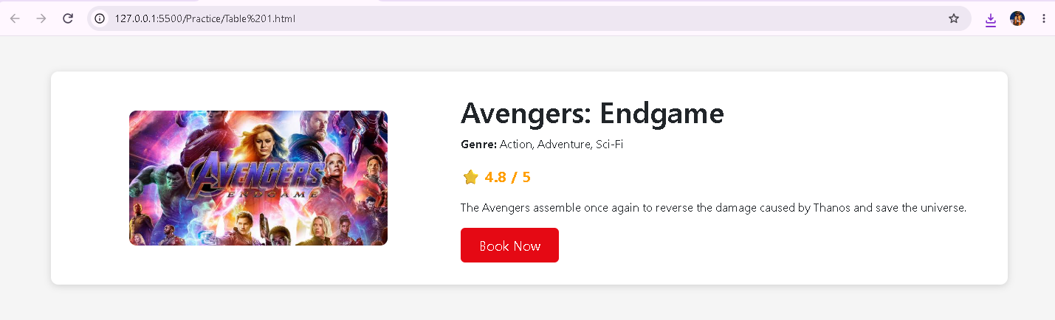

Q.4) Refactor your 2-column layout to be mobile-friendly: make the columns stack vertically on screens smaller than 576px using Bootstrap's responsive grid classes.<br><br><em><strong>Hint:</strong> Try using col-12 for xs and col-6 for md and above.</em>
Ans).
<!DOCTYPE html>
<html lang="en">
<head>
<meta charset="UTF-8">
<meta name="viewport" content="width=device-width, initial-scale=1.0">

<title>Responsive Movie Details</title>

<!-- Bootstrap CSS -->
<link href="https://cdn.jsdelivr.net/npm/bootstrap@5.3.3/dist/css/bootstrap.min.css" rel="stylesheet">

<style>
body {
background-color: #f5f5f5;
}

.movie-section {
background-color: white;
padding: 30px;
border-radius: 10px;
box-shadow: 0 2px 10px rgba(0, 0, 0, 0.15);
}

.movie-poster {
width: 100%;
max-width: 350px;
border-radius: 10px;
}

.rating {
font-size: 20px;
font-weight: bold;
color: #ff9f00;
}

.book-btn {
background-color: #e50914;
color: white;
border: none;
padding: 10px 25px;
font-size: 18px;
}
</style>
</head>

<body>

<div class="container py-5">

<div class="movie-section">

<div class="row align-items-center">

<!-- Movie Poster -->
<div class="col-12 col-md-6 text-center mb-4 mb-md-0">
<img src="/Avengers - End Game.jpg"
alt="Avengers: End Game"
class="movie-poster">
</div>

<!-- Movie Details -->
<div class="col-12 col-md-6">

<h1>Avengers: Endgame</h1>

<p><strong>Genre:</strong> Action, Adventure, Sci-Fi</p>

<p class="rating">⭐ 4.8 / 5</p>

<p>
The Avengers assemble once again to reverse the damage
caused by Thanos and save the universe.
</p>

<button class="btn book-btn">
Book Now
</button>

</div>

</div>

</div>

</div>
</body>
</html>

Result:
